Online Food Delivery System

1. Creating the tables.

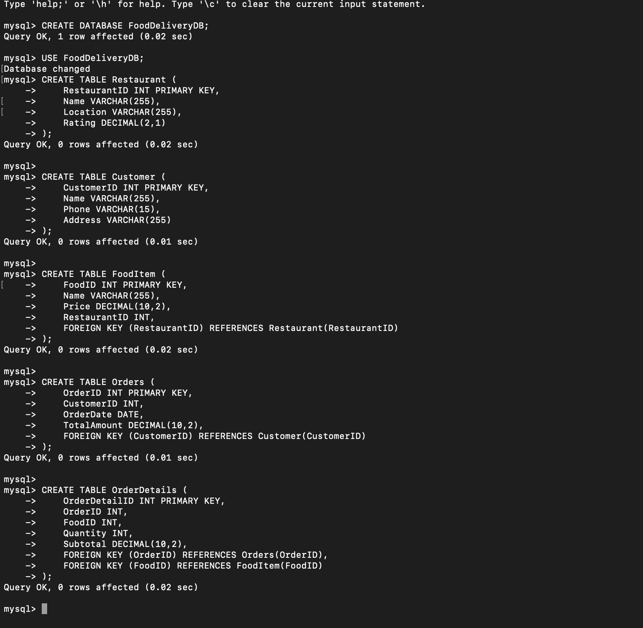

1. Inserting sample data.

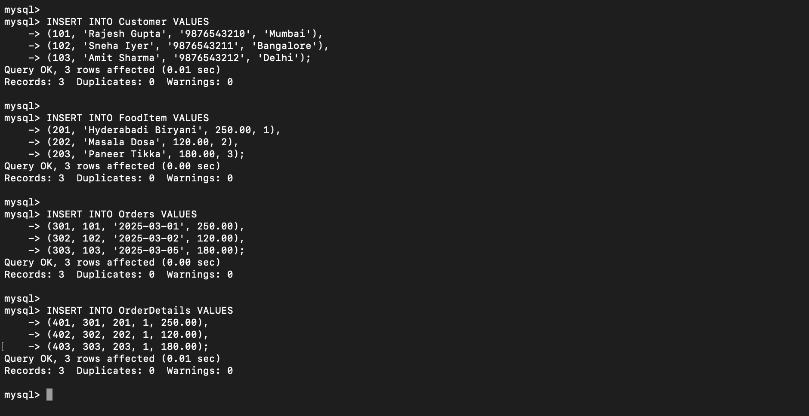

1. Retrieve the total number of orders placed by each customer.

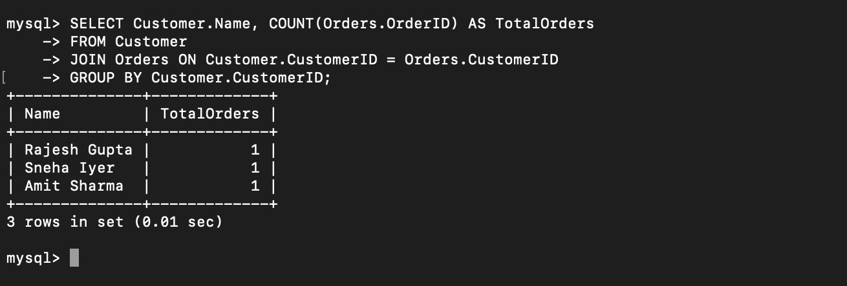

1. Display the most popular food item based on orders.

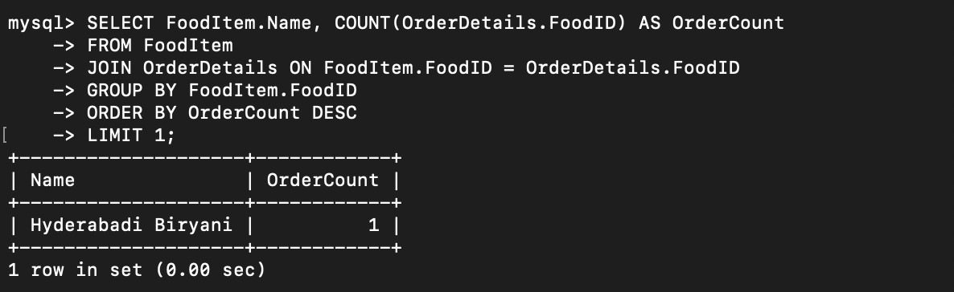

1. Find restaurants with the highest ratings.

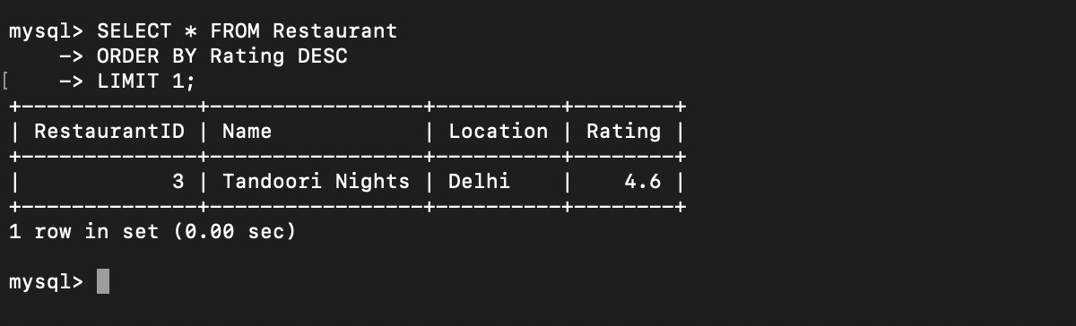

1. Retrieve total sales of each restaurant.

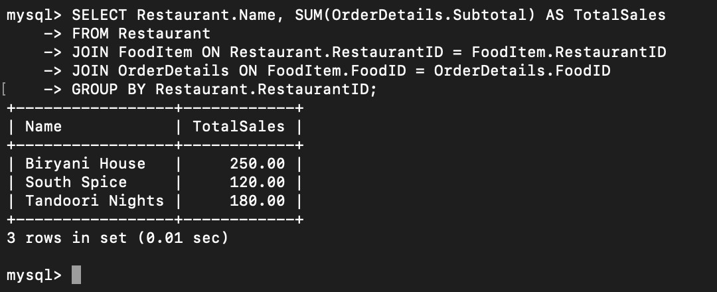

1. Display details of orders placed in the last 7 days.

